**FINAL PROJECT REPORT**

**PROJECT NAME:** UNIX SHELL & HISTROY FEATURE

**GROUP MEMBERS:**

* FARHAN IRFAN
* ABDUL HASEEB
* ZOHAIR ADIL KHAN
* TAHA AHMED ZAIDI
* ARSAL KHAN

**INTRODUCTION:**

In this project we work on the C language to create our own Unix shell with history feature this Unix shell take input as a string and execute it as a normal shell of Ubuntu. We use the parent child process in this so that we can run the program in the background with “&” sign and without “&” . We also use signals so that when we press ctrl+c it will show the history of commands we execute in the program the history is saved in the buffer and its size is 10 so max 10 commands will show in the history and when we exceed from 10 commands the 1 command will remove and the latest command will add on the top. We can also run the commands from history by typing “! N” where N is the number of list which command exists for example if we want to run the command which is on 3 number in list so we just type “! 3” so it will execute that command. Same for last command when we type “!!” it will execute the last command on the list. We also done the work for wrong command when we enter wrong command it will show error in execution of command. Below are the screen shots of the program execution.

**SCREEN SHOTS:**

1. TAKING STRING INPUT:

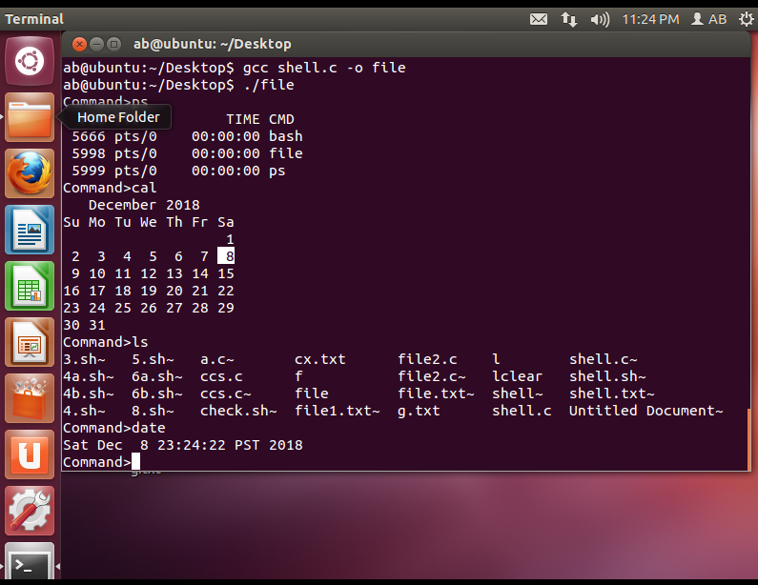

1. SHOWING HISTORY ON PRESSING CTRL + C:

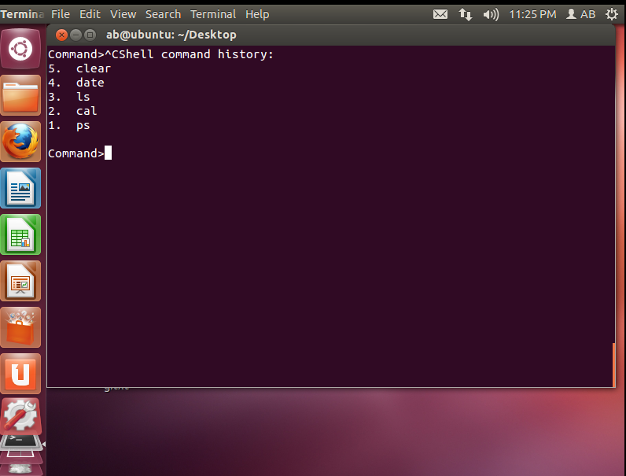

1. SHOWING ERROR WHEN ENTER WRONG COMMAND:

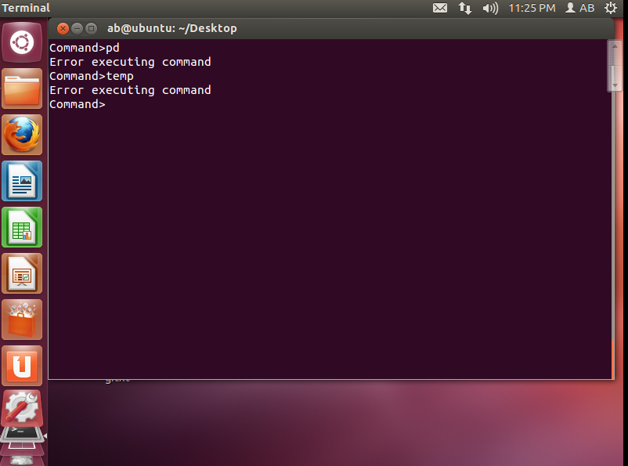

1. RUNNING COMMANDS FROM HISTROY WITH “!” MARK:

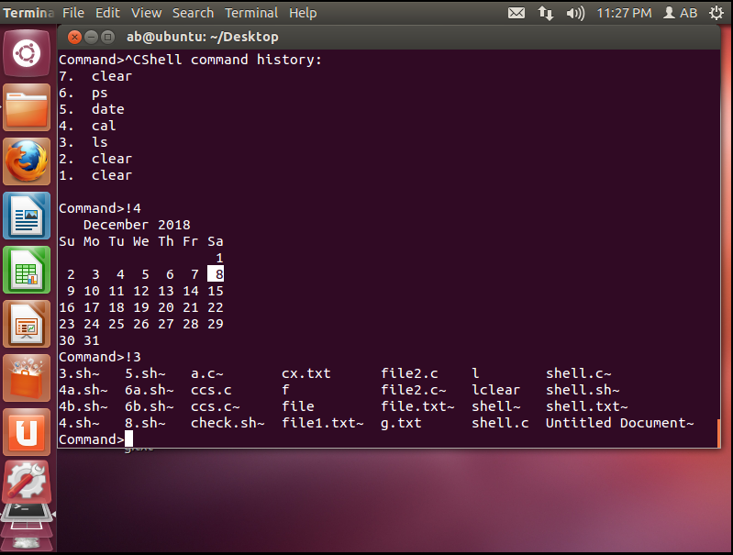

1. RUNNING THE MOST RECENT EXECUTED COMMAND BY “!!” MARK:

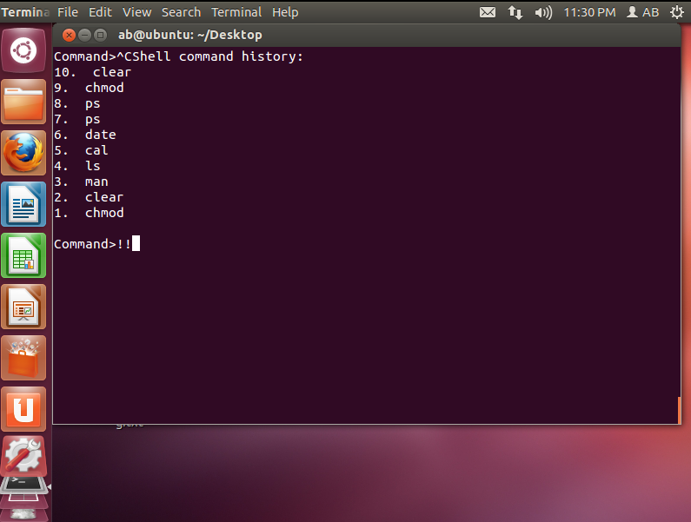

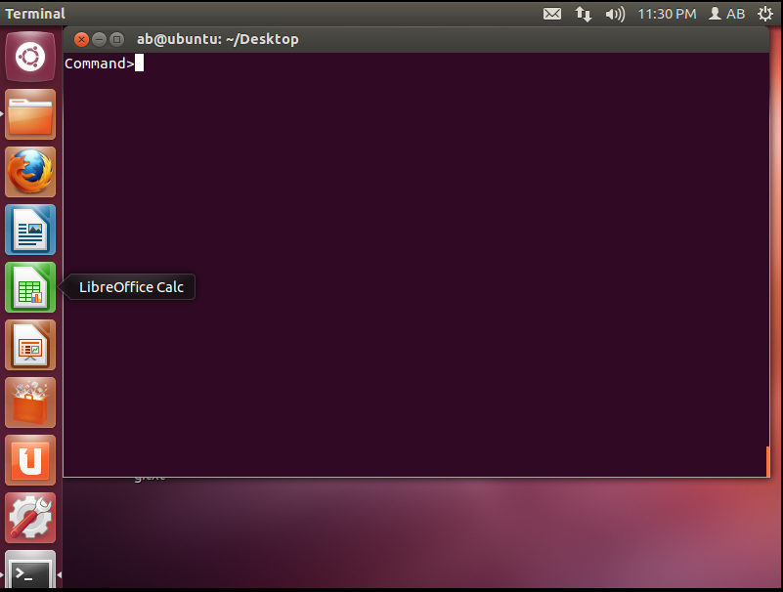

1. RUNNIG THE PROGRAM IN BACKGROUND WITH “&” SIGN:

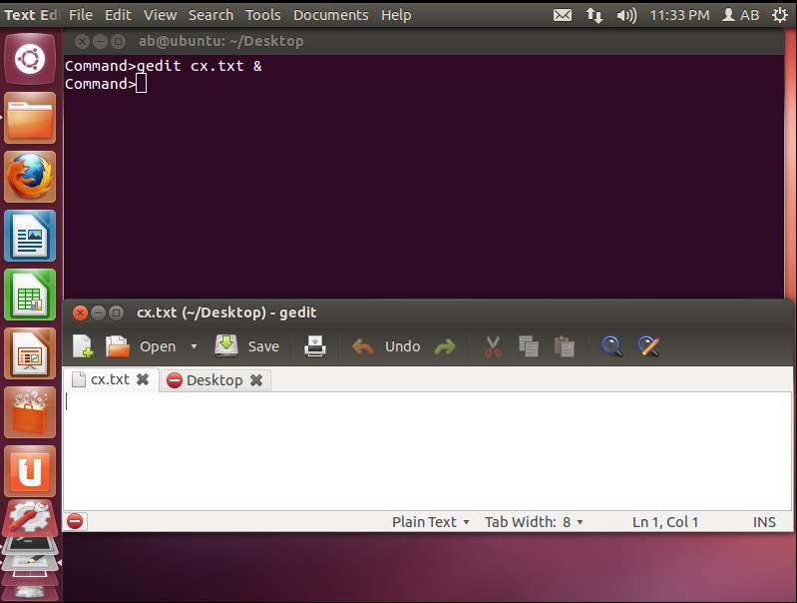

1. WITHOUT “&” SIGN:

